THE MISTAKE ROOM TO PRESENT LOS ANGELES-BORN, GUADALAJARA-BASED ARTIST EDUARDO SARABIA’S FIRST SOLO SHOW IN LA IN NEARLY A DECADE.

Eduardo Sarabia: Drifting on a Dream
September 16 – December 9, 2017

Public Opening Reception: Saturday, September 16, 2017, 6-8pm

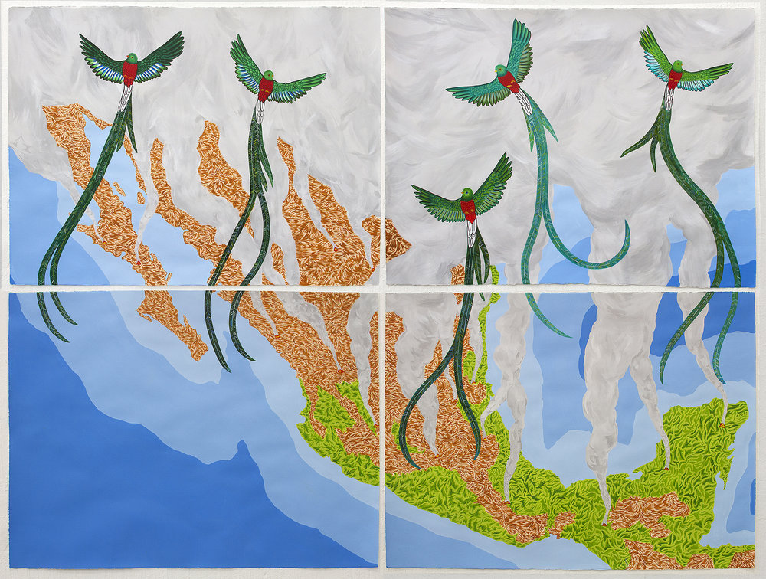
Eduardo Sarabia, The End II, 2017, Acrylic and India Ink on paper, 113 x 151 cm. Courtesy of the artist.

(July 7, 2017. Los Angeles, CA.) In September 2017, The Mistake Room will present Eduardo Sarabia: Drifting on a Dream, the Los Angeles-born, Guadalajara-based artist’s first solo exhibition in his home city in nearly a decade. Made possible through the support of the Mike Kelley Foundation, and coinciding with the Getty Foundation’s PST: LA/LA initiative, the exhibition will reimagine the format of the survey show through an experimental installation environment that will bring together Sarabia’s most iconic projects with a host of new works.

“Eduardo is first and foremost a storyteller,” says Cesar Garcia, TMR’s Executive & Artistic Director and the curator of the exhibition. “While most people are familiar with Eduardo’s ceramic works and his expansive body of drawings, what has been hard to translate in previous exhibitions of his work are the complex processes from which these objects emerge,” he adds.
Born and raised in East LA, Sarabia attended the LA County High School for the Arts and then received a BFA from OTIS in 1999. After graduating, Sarabia spent years living between LA and Berlin before settling permanently in Guadalajara, Mexico where he is currently based. Much of the work he has produced has been informed and inspired by his personal experiences and the interactions he’s had with multiple people and communities over the years.

From producing his own tequila in Guadalajara and then sending it to Berlin to open Salon Aleman (a tequila bar and artist project that went on to become an event-based piece presented at institutions around the world), to setting up a formal expedition company (funded by shares sold to collectors) to search for Mexican revolutionary Pancho Villa’s mythical hidden treasure, Sarabia has created a multiplicity of worlds that audiences only get small glimpses of through the artworks he creates about these projects.
“Sarabia’s practice is about people and about ordinary life experiences that when looked at closely, reveal so much about the broader social, cultural, and political dimensions of our world,” states Garcia. “What we wanted to do with this show is experiment with presentation formats—theater vignettes, ethnographic museum displays, and even bar décor—so that we can highlight the narrative aspect of Sarabia’s broader practice and give audiences a deeper look into the people and stories that inspire what he does within and beyond the studio” he adds.

Organized loosely in three sections—Narco-Pop Culture, Myths: Old & New, and Searching for Treasures—Sarabia’s various projects will be interwoven thematically in order to problematize chronology and to highlight the complex relationships and networks that support a practice informed by the tensions of living between two nations.

Eduardo Sarabia: Drifting on a Dream will open to the public on Saturday, September 16, 2017 from 6-8pm.

A press preview of the show is scheduled for Friday, September 15th, 2017 at 12:00pm.

Eduardo Sarabia: Drifting on a Dream is organized by The Mistake Room and curated by Cesar Garcia, TMR’s Executive & Artistic Director.

Eduardo Sarabia: Drifting on a Dream is made possible through the major support of the Mike Kelley Foundation.
Additional support is provided by The Mistake Room’s Board of Directors, Big Mistake Patron Group, and International and Contemporary Councils.
About The Mistake Room
Committed to Los Angeles, The Mistake Room (TMR) connects the city to peoples, places, and histories that exist well beyond its confines through initiatives at home and abroad. TMR produces and presents ambitious new commissions, research-driven exhibitions, experimental projects, and publications in collaboration with artists creative makers living and working around the world. Realized through new production models that seek to challenge conventional institutional support frameworks, TMR’s projects create new and dynamic relationships with audiences. Our programing incites exchanges that are intellectually rigorous, culturally relevant, and most importantly, reflective of the complexities of our world and time.

Mistake Room Information:
Admission to all exhibitions and programs at The Mistake Room is free. Hours: Wednesday – Saturday, 11am – 6pm. Closed Sundays, Mondays, and national holidays. The Mistake Room is located at 1811 E. 20th Street, Los Angeles, CA 90058. For details please visit www.tmr.la or call (213) 749-1200.

JOIN THE CONVERSATION:

@themistakeroom | #EduardoSarabia | #DriftingOnADream

